Create a Java web program where:

* User can log in and register to the application. (*The program reads and writes data from persistent storage (database)*.)
* After successfully logging in, the application greets the user with a personalized page. It shows the current date and automatically sets an image according to the day of the week.  
    
  *Sample greeting page*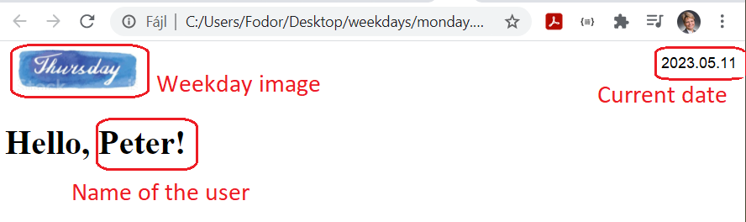

1. Weekday image

* ? @RequestedParam
* ? model.AddAtribute
* ? List<Student> students = new ArrayList<Student>();

# Változtatva

@GetMapping("/homepage")  
public String showHomePage(@RequestParam(required = false) String email, Model model) {

private List<Account> getAccounts() {  
 List accounts = accRepository.findAll();  
 return stories;  
}

public static String getCurrentDayImageName() {  
 DayOfWeek dayOfWeek = LocalDate.*now*().getDayOfWeek();  
 switch (dayOfWeek) {  
 case *MONDAY*:  
 return "monday.png";  
 case *TUESDAY*:  
 return "tuesday.png";  
 case *WEDNESDAY*:  
 return "wednesday.png";  
 case *THURSDAY*:  
 return "thursday.png";  
 case *FRIDAY*:  
 return "friday.png";  
 case *SATURDAY*:  
 return "saturday.png";  
 case *SUNDAY*:  
 return "sunday.png";  
 default:  
 throw new IllegalStateException("Unknown day of the week: " + dayOfWeek);  
 }  
}

<img th:src="@{classpath:/static/images/__${dayImage}__}" th:alt="${dayImage}">